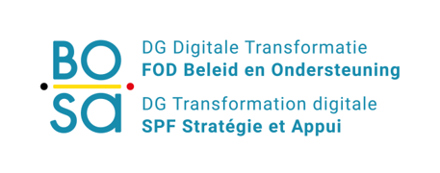
Web service DEFINITION DOCUMENT

PersonHistoryService v3.0

Content

1. Introduction 6

2. Request and response messages 7

2.1. General structure 7
- Request message 7
- Response message 8
- Additional context/entity information 9
- Used code lists and enumerations 9

2.2. getNameHistory(Person number) 9
- Request 9
- Response 10
- Examples 11

2.3. getCivilStateHistory(Person number) 12
- Request 12
- Response 13
- Examples 13

2.4. getNationalityHistory(Person number) 16
- Request 17
- Response 17
- Examples 18

2.5. getLegalCohabitationHistory(Person number) 19
- Request 19
- Response 19
- Examples 19

3. Basic service information 20

3.1. Service access parameters 20

Appendix 20

Reference documents 20

Table 1 Document history
Version | When | Who | What
1.0 | 2019-07-13 | Liesbet D'Hondt | Document setup

Objective of this document

This document describes request and response messages.
In principle the messages are as well documented via annotations in the corresponding XSD file. The documentation in the XSD is limited to the business entities. Relationships between business entities are additionally described in this document.
The complete functional package contains: E-government context, Service Portfolio, Webservice & Operation, Service Message Content, Service Error Codes, Service Test plans and service management documents.

Target group

This document is intended to be read by managers, analysts and developers.

Introduction
The person history service gives the consumer the capability to retrieve historical information concerning particular person details like name, civil state, nationality.

Two organisations managing authentic sources have been defined to manage person details:
The national registry: managing person details of people subscribed to a Belgian administrative authority, i.e. a municipality or embassy
The CBSS: managing person details of people unsubscribed to a Belgian administrative authority, i.e. a municipality or embassy or people not residing in a Belgian municipality
In the ideal situation the person history service should identify the periods for which either one of the authentic sources is mastering the person details. The response is a composition of consulting both sources.
The CBSS is in the event of preparing collecting historical information. The service currently only will offer information from the national registry and will not take care of the period either one of the authentic sources is master of the data.
The first implementation of the service applies to the information of the national registry and does not take care of ‘scratched person’.
Chapter ‘Basic concepts’ describes the general approach concerning historical information.

Request and response messages

General structure

Request message
The structure of the request message for the getNameHistory, getCivilStateHistory, getLegalCohabitationHistory and getNationalityHistory operation are identical.

The request message contains one parameters, the person number.

Input parameter | Description | Precondition
Person number | The person number of the person | The consumer executes a check digit before sending the request.

Input parameter | M/O | Type
Person number | M | 11 digits
M/O: Mandatory/Optional

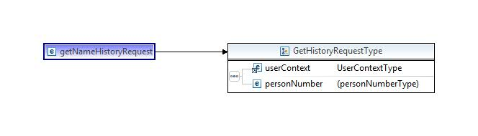

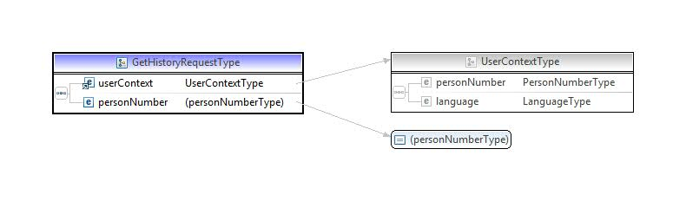

The schemas above show the user context element.

Response message

The structure of the response contains either a business error or the expected response, as described in the reference architecture of the FSB. The expected response might contain warnings.

The error and warning codes are common for the person family. Those error codes are described in the code description document.
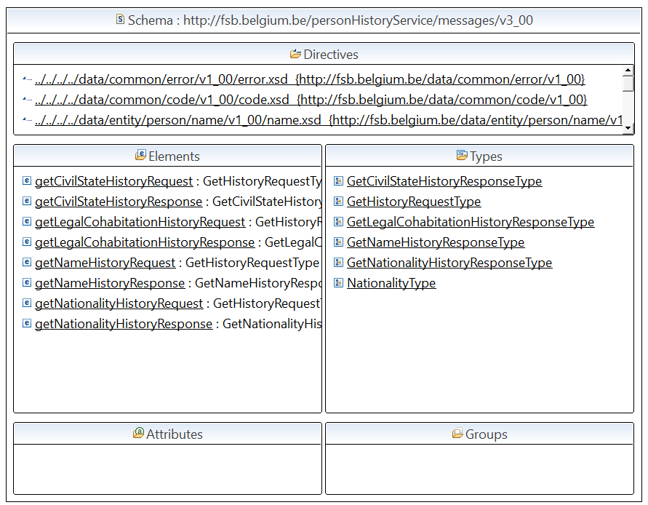
The responses of the getNameHistory, getCivilStateHistory, getLegalCohabitationHistory and getNationalityHistory have a common structure. The response contains a sequence of elements; each element represents the business entity valid at a given moment in time.
The attributes validFrom and validUntil define the validity period.

Additional context/entity information
The representation code for country or nationality is either ISO-3166-1 or NIS. Which representation codes are returned depends on your FSB configuration.

Used code lists and enumerations
The representation code for country or nationality is either ISO-3166-1 or NIS. Which representation codes are returned depends on your FSB configuration.

getNameHistory(Person number)
The operation returns the name history of a person including the actual state.

The name history of a person contains a list of modification dates. Per modification date the last and first names and a reference to the event introducing the name change are given.

Request
<soapenv:Envelope xmlns:head="http://fsb.belgium.be/header" xmlns:soapenv="http://schemas.xmlsoap.org/soap/envelope/" xmlns:v1="http://fsb.belgium.be/data/business/context/v1_00" xmlns:v3="http://fsb.belgium.be/personHistoryService/v3_00" xmlns:v31="http://fsb.belgium.be/personHistoryService/messages/v3_00">
<soapenv:Header>
<v3:sentOnBehalfOf>?</v3:sentOnBehalfOf>
<head:fsbHeader>
<head:messageId>?</head:messageId>
</head:fsbHeader>
</soapenv:Header>
<soapenv:Body>
<v31:getNameHistoryRequest>
<v1:userContext>
<v1:personNumber xsi:nil="true" xmlns:xsi="http://www.w3.org/2001/XMLSchema-instance"/>
<v1:language>nl</v1:language>
</v1:userContext>
<v31:personNumber>58062841307</v31:personNumber>
</v31:getNameHistoryRequest>
</soapenv:Body>

</soapenv:Envelope>

Response
The name history response contains a sequence of nameItem elements, the most recent name on top. Each name modification is grouped into a nameItem element. The nameItem element contains a name and modification element. The name element contains the last and first names. The modification element refers to a legal act.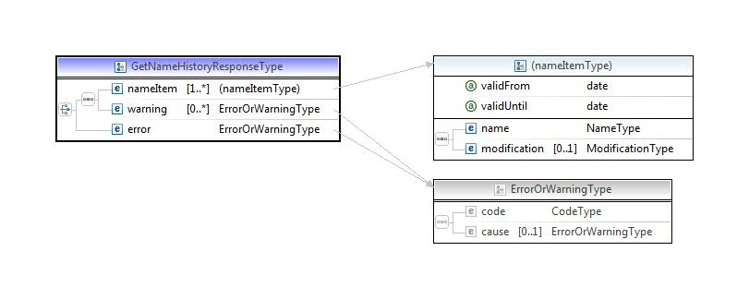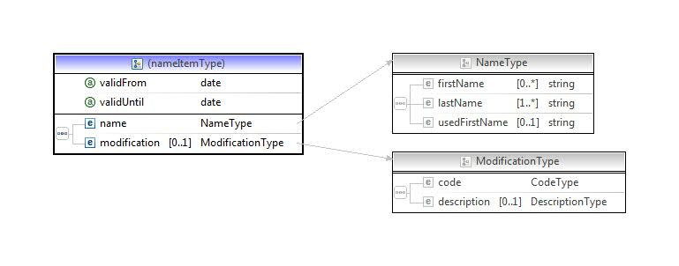

Remark:
One name item is valid at a given moment in time. The validFrom attribute defines the start date of the validity period, the validity period ends when a new name item starts. The attribute validUntil is not completed.
<v3:getNameHistoryResponse xmlns:v3="http://fsb.belgium.be/personHistoryService/messages/v3_00">
<v3:nameItem validFrom="2000-01-01">
<v3:name>
<v1:firstName xmlns:v1="http://fsb.belgium.be/data/entity/person/name/v1_00">Noelle</v1:firstName>
<v1:lastName xmlns:v1="http://fsb.belgium.be/data/entity/person/name/v1_00">Kuckelmanns</v1:lastName>
</v3:name>
<v3:modification>
<v1:code xmlns:v1="http://fsb.belgium.be/data/entity/person/name/v1_00">
<v11:code xmlns:v11="http://fsb.belgium.be/data/common/code/v1_00">01</v11:code>
<v11:description xmlns:v11="http://fsb.belgium.be/data/common/code/v1_00">K.B.</v11:description>
</v1:code>
<v1:description xmlns:v1="http://fsb.belgium.be/data/entity/person/name/v1_00">test nom</v1:description>
</v3:modification>
</v3:nameItem>
<v3:nameItem validFrom="1958-06-28">
<v3:name>
<v1:firstName xmlns:v1="http://fsb.belgium.be/data/entity/person/name/v1_00">Trophine</v1:firstName>
<v1:lastName xmlns:v1="http://fsb.belgium.be/data/entity/person/name/v1_00">Yutue</v1:lastName>
</v3:name>
</v3:nameItem>
</v3:getNameHistoryResponse>

getCivilStateHistory(Person number)
The operation returns the civil state history of a person including the actual state.
The civil state history of a person contains a list of modification dates. Per modification date the civil state, if applicable the person number of the involved partner, the place of the event and a reference to the event introducing the civil state change are given.

Request
<soapenv:Envelope xmlns:head="http://fsb.belgium.be/header" xmlns:soapenv="http://schemas.xmlsoap.org/soap/envelope/" xmlns:v1="http://fsb.belgium.be/data/business/context/v1_00" xmlns:v3="http://fsb.belgium.be/personHistoryService/v3_00" xmlns:v31="http://fsb.belgium.be/personHistoryService/messages/v3_00">
<soapenv:Header>
<v3:sentOnBehalfOf>?</v3:sentOnBehalfOf>
<head:fsbHeader>
<head:messageId>?</head:messageId>
</head:fsbHeader>
</soapenv:Header>
<soapenv:Body>
<v31:getCivilStateHistoryRequest>
<v1:userContext>
<v1:personNumber xsi:nil="true" xmlns:xsi="http://www.w3.org/2001/XMLSchema-instance"/>
<v1:language>nl</v1:language>
</v1:userContext>
<v31:personNumber>?</v31:personNumber>
</v31:getCivilStateHistoryRequest>
</soapenv:Body>
</soapenv:Envelope>

Response
The civil state history response contains a sequence of civilStateItem elements, the most recent civil state on top. Each civilStateItem element contains the civil state and if applicable optional the partner, the place of the event and a reference to a legal act.
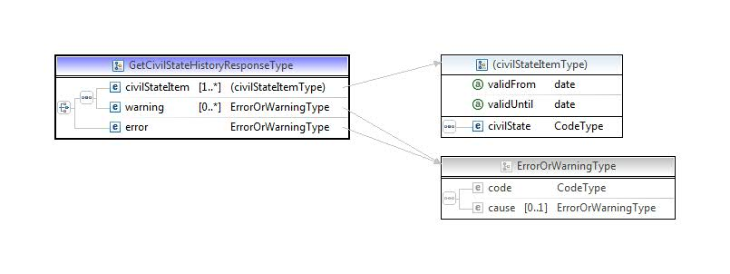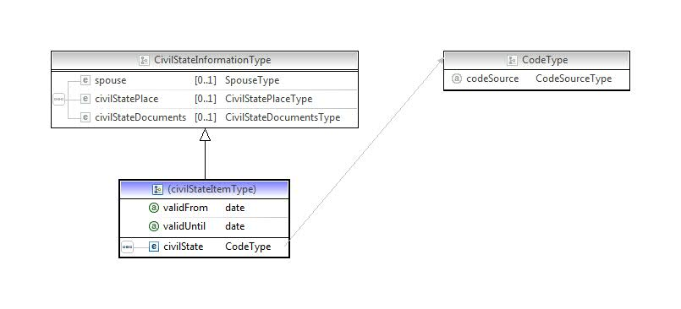
Remark:
One civil state item is valid at a given moment in time. The validFrom attribute defines the start date of the validity period, the validity period ends when a new civil state starts. The attribute vaidUntil is not completed.

Examples
<v3:getCivilStateHistoryResponse xmlns:v3="http://fsb.belgium.be/personHistoryService/messages/v3_00">
<v3:civilStateItem validFrom="2007-08-01">
<v31:spouse xmlns:v31="http://fsb.belgium.be/data/entity/person/civilstate/v3_00">
<v31:number>57062851381</v31:number>
<v31:name>
<v1:firstName xmlns:v1="http://fsb.belgium.be/data/entity/person/name/v1_00">Trophine</v1:firstName>
<v1:lastName xmlns:v1="http://fsb.belgium.be/data/entity/person/name/v1_00">Selbach</v1:lastName>
</v31:name>
<v31:birthDate>
<v2:century xmlns:v2="http://fsb.belgium.be/data/common/date/v2_00">19</v2:century>
<v2:year xmlns:v2="http://fsb.belgium.be/data/common/date/v2_00">57</v2:year>
<v2:month xmlns:v2="http://fsb.belgium.be/data/common/date/v2_00">06</v2:month>
<v2:day xmlns:v2="http://fsb.belgium.be/data/common/date/v2_00">28</v2:day>
</v31:birthDate>
<v31:gender>
<v1:code xmlns:v1="http://fsb.belgium.be/data/common/code/v1_00">1</v1:code>
<v1:description xmlns:v1="http://fsb.belgium.be/data/common/code/v1_00">Male</v1:description>
</v31:gender>
</v31:spouse>
<v31:civilStatePlace xmlns:v31="http://fsb.belgium.be/data/entity/person/civilstate/v3_00"/>
<v31:civilStateDocuments xmlns:v31="http://fsb.belgium.be/data/entity/person/civilstate/v3_00">
<v31:civilStateAct>
<v31:actNumber>3636</v31:actNumber>
</v31:civilStateAct>
<v31:judgement>
<v31:foreignJudgement>
<v31:country>
<v1:code xmlns:v1="http://fsb.belgium.be/data/common/code/v1_00">FR</v1:code>
<v1:description xmlns:v1="http://fsb.belgium.be/data/common/code/v1_00">Frankrijk</v1:description>
</v31:country>
<v31:comment>divorce2</v31:comment>
</v31:foreignJudgement>
</v31:judgement>
<v31:transcription>
<v31:place>
<v1:code xmlns:v1="http://fsb.belgium.be/data/common/code/v1_00">52011</v1:code>
<v1:description xmlns:v1="http://fsb.belgium.be/data/common/code/v1_00">Charleroi</v1:description>
</v31:place>
<v31:date>
<v2:century xmlns:v2="http://fsb.belgium.be/data/common/date/v2_00">20</v2:century>
<v2:year xmlns:v2="http://fsb.belgium.be/data/common/date/v2_00">07</v2:year>
<v2:month xmlns:v2="http://fsb.belgium.be/data/common/date/v2_00">08</v2:month>
<v2:day xmlns:v2="http://fsb.belgium.be/data/common/date/v2_00">01</v2:day>
</v31:date>
</v31:transcription>
</v31:civilStateDocuments>
<v3:civilState>
<v1:code xmlns:v1="http://fsb.belgium.be/data/common/code/v1_00">41</v1:code>
<v1:description xmlns:v1="http://fsb.belgium.be/data/common/code/v1_00">Uit de echt gescheiden</v1:description>
</v3:civilState>
</v3:civilStateItem>
<v3:civilStateItem validFrom="2005-06-28">
<v31:spouse xmlns:v31="http://fsb.belgium.be/data/entity/person/civilstate/v3_00">
<v31:number>57062851381</v31:number>
<v31:name>
<v1:firstName xmlns:v1="http://fsb.belgium.be/data/entity/person/name/v1_00">Trophine</v1:firstName>
<v1:lastName xmlns:v1="http://fsb.belgium.be/data/entity/person/name/v1_00">Selbach</v1:lastName>
</v31:name>
<v31:birthDate>
<v2:century xmlns:v2="http://fsb.belgium.be/data/common/date/v2_00">19</v2:century>
<v2:year xmlns:v2="http://fsb.belgium.be/data/common/date/v2_00">57</v2:year>
<v2:month xmlns:v2="http://fsb.belgium.be/data/common/date/v2_00">06</v2:month>
<v2:day xmlns:v2="http://fsb.belgium.be/data/common/date/v2_00">28</v2:day>
</v31:birthDate>
<v31:gender>
<v1:code xmlns:v1="http://fsb.belgium.be/data/common/code/v1_00">1</v1:code>
<v1:description xmlns:v1="http://fsb.belgium.be/data/common/code/v1_00">Male</v1:description>
</v31:gender>
</v31:spouse>
<v31:civilStatePlace xmlns:v31="http://fsb.belgium.be/data/entity/person/civilstate/v3_00">
<v31:municipality>
<v1:code xmlns:v1="http://fsb.belgium.be/data/common/code/v1_00">52011</v1:code>
<v1:description xmlns:v1="http://fsb.belgium.be/data/common/code/v1_00">Charleroi</v1:description>
</v31:municipality>
</v31:civilStatePlace>
<v31:civilStateDocuments xmlns:v31="http://fsb.belgium.be/data/entity/person/civilstate/v3_00">
<v31:civilStateAct>
<v31:actNumber>8989</v31:actNumber>
</v31:civilStateAct>
</v31:civilStateDocuments>
<v3:civilState>
<v1:code xmlns:v1="http://fsb.belgium.be/data/common/code/v1_00">20</v1:code>
<v1:description xmlns:v1="http://fsb.belgium.be/data/common/code/v1_00">Gehuwd</v1:description>
</v3:civilState>
</v3:civilStateItem>
<v3:civilStateItem validFrom="1958-06-28">
<v3:civilState>
<v1:code xmlns:v1="http://fsb.belgium.be/data/common/code/v1_00">10</v1:code>
<v1:description xmlns:v1="http://fsb.belgium.be/data/common/code/v1_00">Ongehuwd</v1:description>
</v3:civilState>
</v3:civilStateItem>
</v3:getCivilStateHistoryResponse>

getNationalityHistory(Person number)
The operation returns the nationality history of a person including the actual state. A person can have multiple nationalities at the same time.
The nationality history of a person contains a list of modification dates. Per modification date a list of nationalities (a person can have multiple nationalities) and references to the document introducing the nationality change are given.

Request
<soapenv:Envelope xmlns:head="http://fsb.belgium.be/header" xmlns:soapenv="http://schemas.xmlsoap.org/soap/envelope/" xmlns:v1="http://fsb.belgium.be/data/business/context/v1_00" xmlns:v3="http://fsb.belgium.be/personHistoryService/v3_00" xmlns:v31="http://fsb.belgium.be/personHistoryService/messages/v3_00">
<soapenv:Header>
<v3:sentOnBehalfOf>?</v3:sentOnBehalfOf>
<head:fsbHeader>
<head:messageId>?</head:messageId>
</head:fsbHeader>
</soapenv:Header>
<soapenv:Body>
<v31:getNationalityHistoryRequest>
<v1:userContext>
<v1:personNumber xsi:nil="true" xmlns:xsi="http://www.w3.org/2001/XMLSchema-instance"/>
<v1:language>nl</v1:language>
</v1:userContext>
<v31:personNumber>?</v31:personNumber>
</v31:getNationalityHistoryRequest>
</soapenv:Body>

</soapenv:Envelope>

Response
The nationality history response contains a sequence of nationalities, the most recent nationality on top.
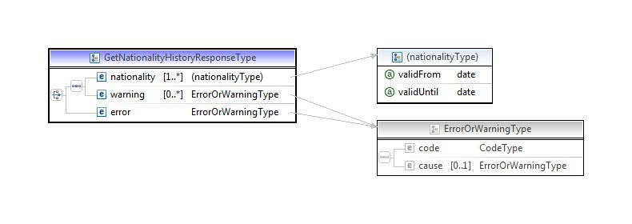
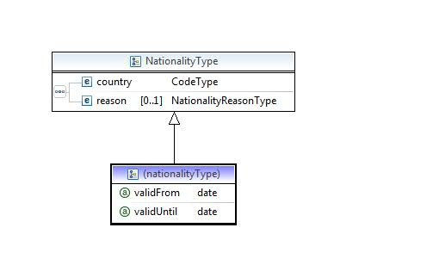
Remark:
People may have multiple nationalities at a time. The attributes validFrom and validUntil define the validity period.
ISSUE:
The validUntil attribute is currently not complete due to unclear specifications of multiple nationalities in the national registry. The issue will be solved when clarified.

Examples
<v3:getNationalityHistoryResponse xmlns:v3="http://fsb.belgium.be/personHistoryService/messages/v3_00">
<v3:nationality validFrom="2012-06-01">
<v3:country>
<v1:code xmlns:v1="http://fsb.belgium.be/data/common/code/v1_00">IT</v1:code>
<v1:description xmlns:v1="http://fsb.belgium.be/data/common/code/v1_00">Italië</v1:description>
</v3:country>
</v3:nationality>
<v3:nationality validFrom="1963-08-14">
<v3:country>
<v1:code xmlns:v1="http://fsb.belgium.be/data/common/code/v1_00">BE</v1:code>
<v1:description xmlns:v1="http://fsb.belgium.be/data/common/code/v1_00">Belg</v1:description>
</v3:country>
</v3:nationality>
</v3:getNationalityHistoryResponse>

getLegalCohabitationHistory(Person number)
The operation returns the legal cohabitation history of a person including the actual state.
The legal cohabitation history of a person contains a list of legal cohabitation history items with modification dates. Per modification date the legal cohabitation state, declaration or cessation, the registration date and information about the cessation or registration of the legal cohabitation are given.

Request
<soapenv:Envelope xmlns:head="http://fsb.belgium.be/header" xmlns:soapenv="http://schemas.xmlsoap.org/soap/envelope/" xmlns:v1="http://fsb.belgium.be/data/business/context/v1_00" xmlns:v3="http://fsb.belgium.be/personHistoryService/v3_00" xmlns:v31="http://fsb.belgium.be/personHistoryService/messages/v3_00">
<soapenv:Header
<v3:sentOnBehalfOf>?</v3:sentOnBehalfOf>
<head:fsbHeader>
<head:messageId>?</head:messageId>
</head:fsbHeader>
</soapenv:Header>
<soapenv:Body>
<v31:getLegalCohabitationHistoryRequest>
<v1:userContext>
<v1:personNumber xsi:nil="true" xmlns:xsi="http://www.w3.org/2001/XMLSchema-instance"/>
<v1:language>nl</v1:language>
</v1:userContext>
<v31:personNumber>?</v31:personNumber>
</v31:getLegalCohabitationHistoryRequest>
</soapenv:Body>
</soapenv:Envelope>

Response
The legal cohabitation history response contains a sequence of legalCohabitationHistoryItem elements, the most recent legal cohabitation history item on top.
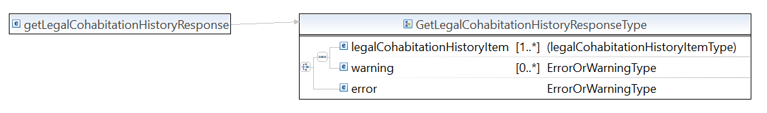
Each legalCohabitationHistoryItem element contains legagCohabitationInformation. For more information on this complexType, please visit the Canonical Data Model PersonServices documentation.
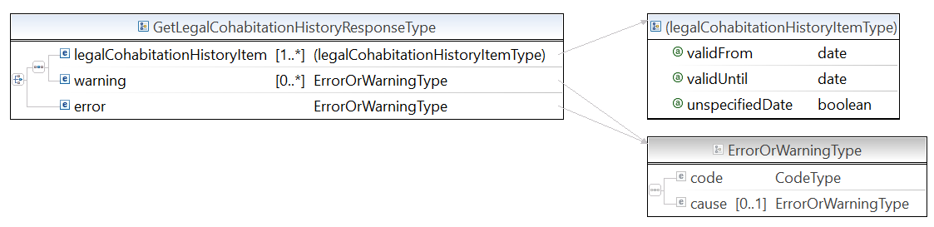
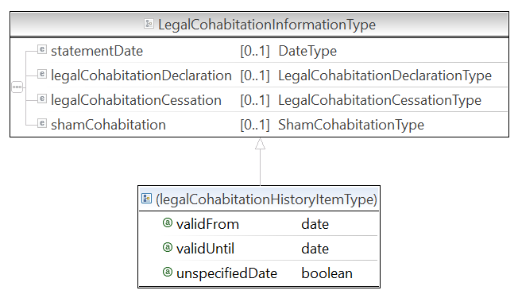

Examples
<v3:getLegalCohabitationHistoryResponse xmlns:v3="http://fsb.belgium.be/personHistoryService/messages/v3_00">
<v3:legalCohabitationHistoryItem validFrom="2006-05-05">
<v2:legalCohabitationCessation xmlns:v2="http://fsb.belgium.be/data/entity/person/legalcohabitation/v2_00">
<v2:registrationDate xsi:nil="true" xmlns:xsi="http://www.w3.org/2001/XMLSchema-instance"/>
<v2:reason>
<v1:code xmlns:v1="http://fsb.belgium.be/data/common/code/v1_00">04</v1:code>
<v1:description xmlns:v1="http://fsb.belgium.be/data/common/code/v1_00">Eenzijdige verklaring</v1:description>
</v2:reason>
<v2:cessationPlace>
<v2:municipality>
<v1:code xmlns:v1="http://fsb.belgium.be/data/common/code/v1_00">21001</v1:code>
<v1:description xmlns:v1="http://fsb.belgium.be/data/common/code/v1_00">Anderlecht</v1:description>
</v2:municipality>
</v2:cessationPlace>
</v2:legalCohabitationCessation>
</v3:legalCohabitationHistoryItem>
<v3:legalCohabitationHistoryItem validFrom="2005-09-01">
<v2:legalCohabitationDeclaration xmlns:v2="http://fsb.belgium.be/data/entity/person/legalcohabitation/v2_00">
<v2:registrationDate>
<v21:century xmlns:v21="http://fsb.belgium.be/data/common/date/v2_00">20</v21:century>
<v21:year xmlns:v21="http://fsb.belgium.be/data/common/date/v2_00">05</v21:year>
<v21:month xmlns:v21="http://fsb.belgium.be/data/common/date/v2_00">09</v21:month>
<v21:day xmlns:v21="http://fsb.belgium.be/data/common/date/v2_00">01</v21:day>
</v2:registrationDate>
<v2:legalCohabitationPartner>
<v2:number>73010338596</v2:number>
<v2:name>
<v1:firstName xmlns:v1="http://fsb.belgium.be/data/entity/person/name/v1_00">Jean</v1:firstName>
<v1:lastName xmlns:v1="http://fsb.belgium.be/data/entity/person/name/v1_00">Sermon</v1:lastName>
</v2:name>
<v2:birthDate>
<v21:century xmlns:v21="http://fsb.belgium.be/data/common/date/v2_00">19</v21:century>
<v21:year xmlns:v21="http://fsb.belgium.be/data/common/date/v2_00">73</v21:year>
<v21:month xmlns:v21="http://fsb.belgium.be/data/common/date/v2_00">01</v21:month>
<v21:day xmlns:v21="http://fsb.belgium.be/data/common/date/v2_00">03</v21:day>
</v2:birthDate>
<v2:gender>
<v1:code xmlns:v1="http://fsb.belgium.be/data/common/code/v1_00">1</v1:code>
<v1:description xmlns:v1="http://fsb.belgium.be/data/common/code/v1_00">Male</v1:description>
</v2:gender>
</v2:legalCohabitationPartner>
<v2:legalCohabitationPlace>
<v2:municipality>
<v1:code xmlns:v1="http://fsb.belgium.be/data/common/code/v1_00">21001</v1:code>
<v1:description xmlns:v1="http://fsb.belgium.be/data/common/code/v1_00">Anderlecht</v1:description>
</v2:municipality>
</v2:legalCohabitationPlace>
<v2:registrationOfficer>
<v2:registrationOfficerName>Leemans Arnold</v2:registrationOfficerName>
<v2:registrationPlace>
<v2:municipality>
<v1:code xmlns:v1="http://fsb.belgium.be/data/common/code/v1_00">23077</v1:code>
<v1:description xmlns:v1="http://fsb.belgium.be/data/common/code/v1_00">Sint-Pieters-Leeuw</v1:description>
</v2:municipality>
</v2:registrationPlace>
</v2:registrationOfficer>
</v2:legalCohabitationDeclaration>
</v3:legalCohabitationHistoryItem>
</v3:getLegalCohabitationHistoryResponse>

Basic service information

Service access parameters
Table 3 Service access parameters get person history information
Endpoint URL (Test & Acceptance) | https://fsb.services.int.belgium.be/PersonServices/3.0/PersonHistoryService
Endpoint URL (Production) | https://fsb.services.prd.belgium.be/PersonServices/3.0/PersonHistoryService
Message exchange pattern(s) | Synchronous
Message protocol | SOAP
Transport-level security | 1-way SSL with digital certificate
Message-level security | WS-Security X.509 certificate token for Timestamp signing in SHA256 and message body signing in SHA 256, response contains a timestamp and payload also signed in SHA256

Appendix

Reference documents
Service code description document of the person service family, including the error handling
Instructions National Registry
- Description of the Information Types (01/06/2021)
Remarks
- The documents above are subject of change. The hyperlink above contains a date notation. Check the web site of the RNR for the most accurate version.
- The hyperlinks refer to the Dutch language version of those documents, the French language versions are available as well.

Check rules are : When born before January 1° 2000 XXXXXX YYY ZZ where 97-mod(XXXXXXYYY,97)=ZZ; when born after December 31° 1999: XXXXXX YYY ZZ where 97-mod(2XXXXXXYYY,97)=ZZ.

