Web service operation AND Service message description

certificatesPersonMonDossierService v1.0

Content

1. Introduction 5

2. Request and response messages 6

2.1. General structure 6
- 2.1.1. Request message certificatesPersonMonDossier 6
- 2.1.2. Response message certificatesPersonMonDossier 6
- 2.1.3. Used code lists and enumerations 6

2.2. certificatesPersonMonDossier 7
- 2.2.1. Request 7
- 2.2.2. Response 9

3. Detailed Capability Scenario’s 10

3.1. Operation certificatesPersonMonDossier 10
- 3.1.1. STANDARD SCENARIO 10
- 3.1.2. ALTERNATIVE SCENARIO INVALID IDENTIFICATION NUMBER OR INVALID DOCUMENTTYPE 10

4. Basic concepts 11

4.1. Person Number 11

5. Basic service information 12

5.1. Service access parameters 12

Appendix 12

SendOnBehalfOf 12

Table 1 Document history
Version | When | Who | What
1.0 | 2024-03-06 | Liesbet D'Hondt | Document setup

Objective of this document

This document describes request and response messages.
In principle the messages are as well documented via annotations in the corresponding XSD file. The documentation in the XSD is limited to the business entities. Relationships between business entities are additionally described in this document.
The complete functional package contains: E-government context, Service Portfolio, Webservice & Operation, Service Message Content, Service Error Codes, Service Testplans and service management documents.

Target group

This document is intended to be read by managers, analysts and developers.

Introduction
Related to person information, FOD BOSA VDSD is offering services for:
- Searching a person by name or address
- Getting person basic information
- Getting person extended information, including historical data
- Getting a person’s household information
- Searching the filiation information of a person, both ascending and descending
- Getting the signature displayed on the e-Id card
- Getting the photo displayed on the e-Id card
- Getting the certificates of a person

- This document handles the web services for getting the certificates that can be requested for a person. The information is retrieved from the National Register.

Functionality | operation | Wsdl service name
Getting the different certificates of a person | certificatesPersonMonDossier | certificatesPersonMonDossierService

Request and response messages

General structure

Request message certificatesPersonMonDossier
The request contains the standard person service context element and two operation particular input parameters. The request is composed of the national number of the person whose certificate is needed as well as the document type / type of certificate that is requested. These parameters are required.

Response message certificatesPersonMonDossier
The expected output message contains a document. The document element contains the base 64 encoded PDF of the certificate.
The output message may contain errors and warnings. These errors and warnings are described in the PersonServices error and warning description document.

Used code lists and enumerations
The schema definitions contain a reference to the code list. Please consult the XSD file for the source of a code list.
The language code list follows the rule above. Mark that the national registry only allows Dutch, French or German. Other languages have at the national registry an input validation error as a consequence.

certificatesPersonMonDossier
The certificatesPersonMonDossier operation returns a document element based on the identification number and the requested document type. 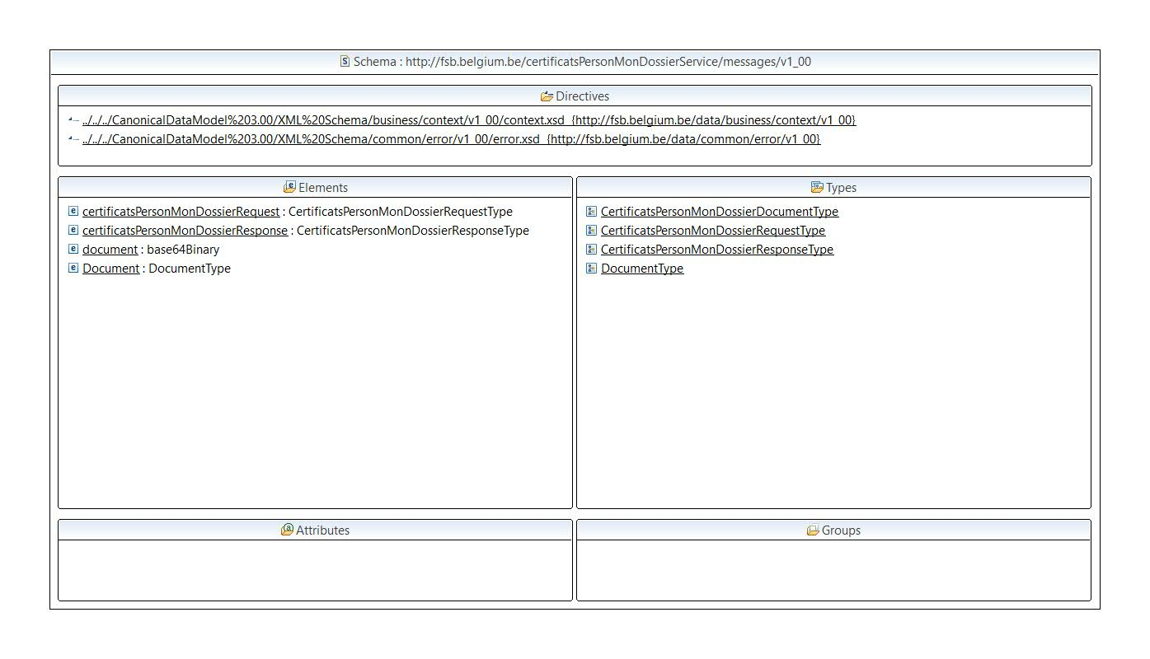
Figure 1 Service messages overview

Request
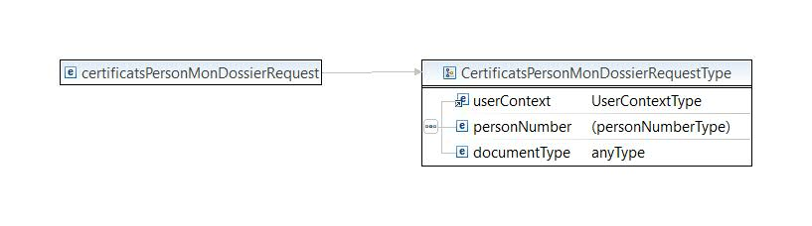
Figure 2 Overview of a request
The user context element defines the user who is making the request and his language. The language defines the language the service returns error, warning and other descriptions. The user, identified via the person number, is required to authenticate and authorize the requestor.
Remark that the authentication and authorization at the NR are respectively requestor (person) and application based.

On top of the user context element as described above the following parameters are required:

Input parameter | Optional / Mandatory | Description | Remark
personNumber | M | The person number of the person whose certificate is being requested. | Check digit executed by the consumer before sending the request and check digit validated by the national registry
documentType | M | This parameter is used for specifying which certificate is being requested | Possible values are :  LegalCohabition  RegisterExtract  MainResidence  HistoricMainResidence  HouseHold  Life  BelgianNationality  VotersRegister  ResidencePurposeMarriage  BurialMethod

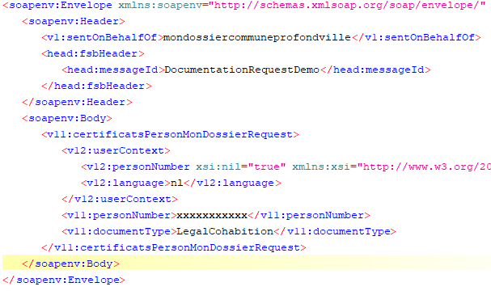
Figure 3 Example of request

Response
Independent of the certificatesPersonMonDossier service or operation, the response message contains a warning and error element at response level. The service and operation response dependant part is described below in an operation specific paragraph.
Each response may contain an error or one or more warning elements. The response error and warning elements have an impact on the complete response.
Error and warning codes are described in the person service error code list and description document.
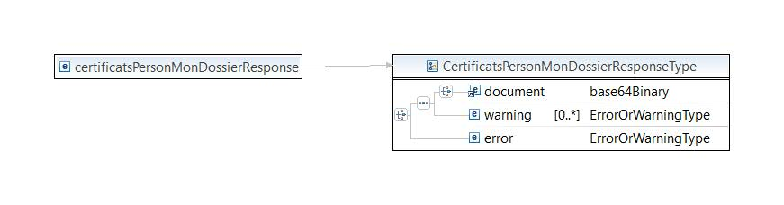
Figure 4 Overview of a response
Output parameters | Description
document | Base64 encoding of the requested certificate in PDF format
The response contains in case of business errors an error element. The error element is not described as output.

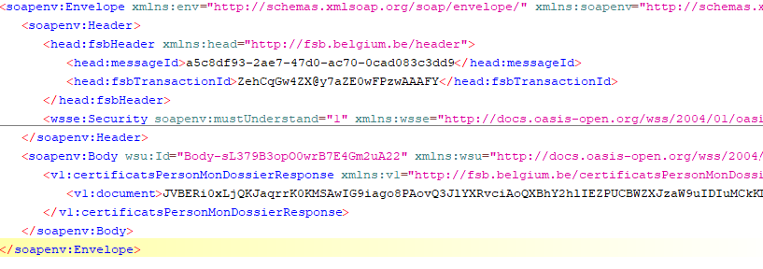
Figure 5 Example of a response

Detailed Capability Scenario’s

Operation certificatesPersonMonDossier
Based on the person number and documentType parameter, the service returns the requested certificate of a person. This information is retrieved from the National Register. The only input parameters are the person number and document type.

STANDARD SCENARIO
The person number is a (correct) national identification number and the document type element contains one of the values mentioned above in de values list; the person is not scratched and has not obtained a new identification number.
The service responds a document element. The source of the document is the NR.

ALTERNATIVE SCENARIO INVALID IDENTIFICATION NUMBER OR INVALID DOCUMENTTYPE
The person number is an invalid national identification number or the document type submitted was invalid.
The service responds a Soap Fault.

Basic concepts
Before describing the functionality of the person services some background information is given to obtain a common ground of person related information in Belgium.

Person Number
A person number is a national identification number (in case the national registry has attributed the number) or a bis number (in case the CBSS has attributed the number). A person number is a number of 11 digits and identifies a person uniquely. This number is also called the social security inscription number SSIN.
Layout of the person number:
Position | Description | Remark
1-6 | Birthday in YYMMDD format | In some cases the birthday is unknown or not precise. The year is known, but not the month and or day. In those cases the month and or day are 00.  Bis numbers attributed by the Crossroads Bank for Social Security have the month value plus 20 (20-32) or plus 40 (40-52).
7-9 | Serial number | In case of a national number a male persons have an odd number and a female an even number.
10-11 | Check digit | Based on mod97

Basic service information

Service access parameters
Table 3 Service access parameters get person certificate information
Endpoint URL (Test & Acceptance) | https://fsb.services.int.belgium.be/PersonServices/1.0/CertificatsPersonMonDossierService
Endpoint URL (Production) | https://fsb.services.pr.belgium.be/PersonServices/1.0/CertificatsPersonMonDossierService
Message exchange pattern(s) | Synchronous
Message protocol | SOAP
Transport-level security | 1-way SSL with digital certificate
Message-level security | WS-Security X.509 certificate token for Timestamp signing in SHA256 and message body signing in SHA 256, response contains a timestamp and payload also signed in SHA256

Appendix

SendOnBehalfOf
The soap request has:
- In the soap header a sentOnBehalfOf element containing the name of the commune (for example: “mondossiercommuneprofondville”)
- In the usercontext element can also be nil specified

